MAC 272

Project Report

**Team Names:** Marie/Raju

**What your project is about?**

We did the Library Management System for our project. The Library Management System is used to operate and manage huge amount of data generated from libraries. The main purpose of the website is to better assist librarians to manage a book library and save them valuable time. Instead of having to manually do all the work the system does the work for them. It keeps track of all the resources that's available in the library. It performs all tasks for a librarian and makes library management quick and convenient. There is no need to keep a manual track of important information which makes less chances of making mistakes. Members and book information can be stored, managed, updated, organized, shared, deleted and retrieved from the database.

**Site map and list of functions (features) that the website performs.**

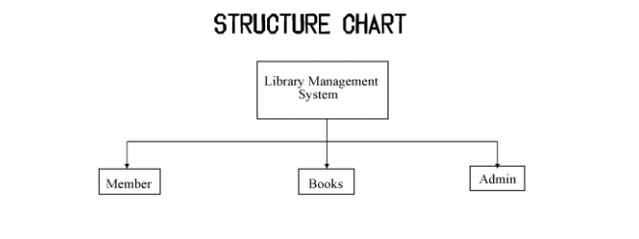

**System**

Stores member and book details (member id, name, password, email, address, book id, title, author name, date and year of publication, cost etc.) The system will be able to retrieve member information and books by id, isbn, category, title, author, date, publication year, etc. This will allow both members and staff to quickly find what they are looking for and save time. The system also allows members to search for books and borrow or return them whenever they want. Admin will have to approve the request, but it is super easy with the help of the system they can quickly approve with just a click of a button. Members will have instant access to the reading materials once they create a user account and login. The system validates username and password. It can search, retrieve and share information quickly. Members can easily search for books by their title, author, and category. The website will show information like who took what book or what books have been checked-out by a specific member.

**Admin**

Can manage reading materials that’s available and user accounts. The system will allow staff to add/update/delete members and books. When a member makes a request for a book a librarian will be able to approve the request. All they need to do is retrieve the information from the system and with just a click of a button they can issue and return books and see all books that’s available in the library. This makes the librarian’s job fast and easy. They can easily update data in the system and get their work done much faster.

**Member**

Create an account: Anyone can become a member of the library system by simply creating an online account. Members can manage their accounts by simply logging into the system. They will then see all the books available to them. They can then choose to request a book or borrow something that’s already stored in the system. They can update their information and reset their password if they forget it.

**What technologies and tools you used to develop your project?**

My team member and I used PHP, MYSQL, HTML, CSS, JavaScript, and Stylish themes. I worked on the description/functions and purpose of the website (we both decided on the functions to exclude/include) I created tables for members, librarians with their information in the database and did some of the HTML and JavaScript. Raju coded the entire system on his side. He added data to database, as well as HTML and JavaScript/CSS. I did the same on my side. I added one extra function to the system code which is a category for the books. I recorded the video showing how the project works and wrote the final report. Raju did the presentation and he helped me troubleshoot things on my side when I could not get the system to work properly because of database issues. Raju and I work well together, and we got started on our project right away. We knew since the first day what we wanted to do and what tools we needed to use in order to achieve it.

**Screen shoots of your website**

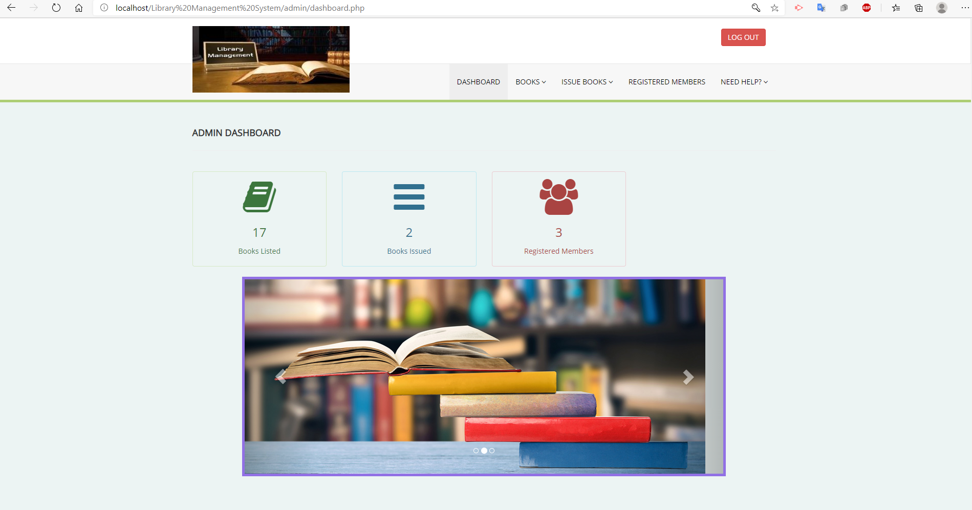

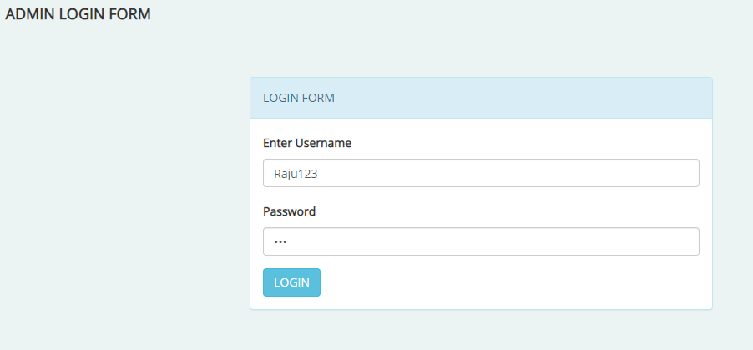

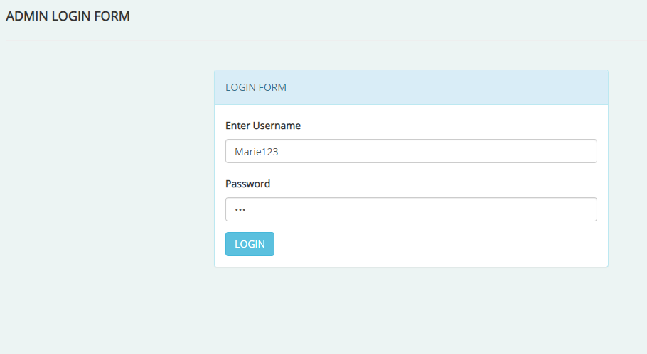

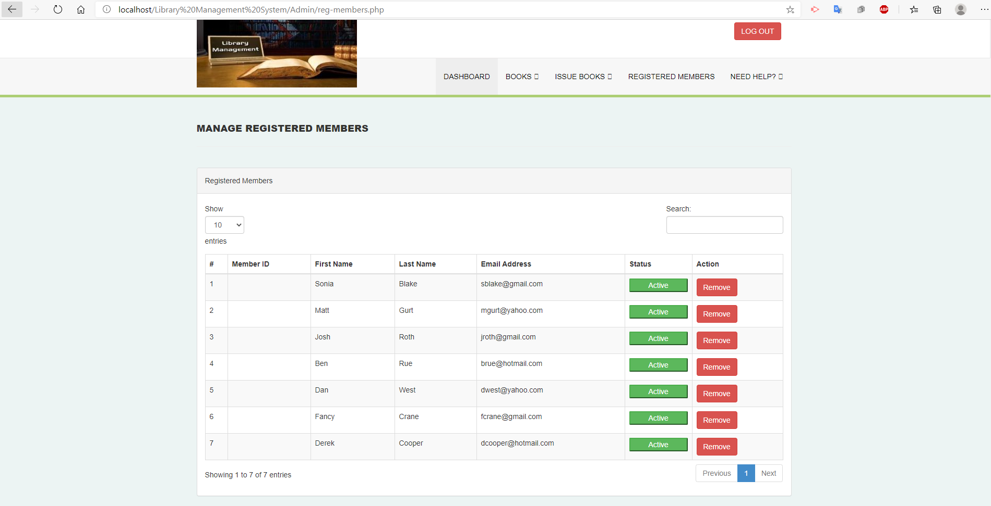

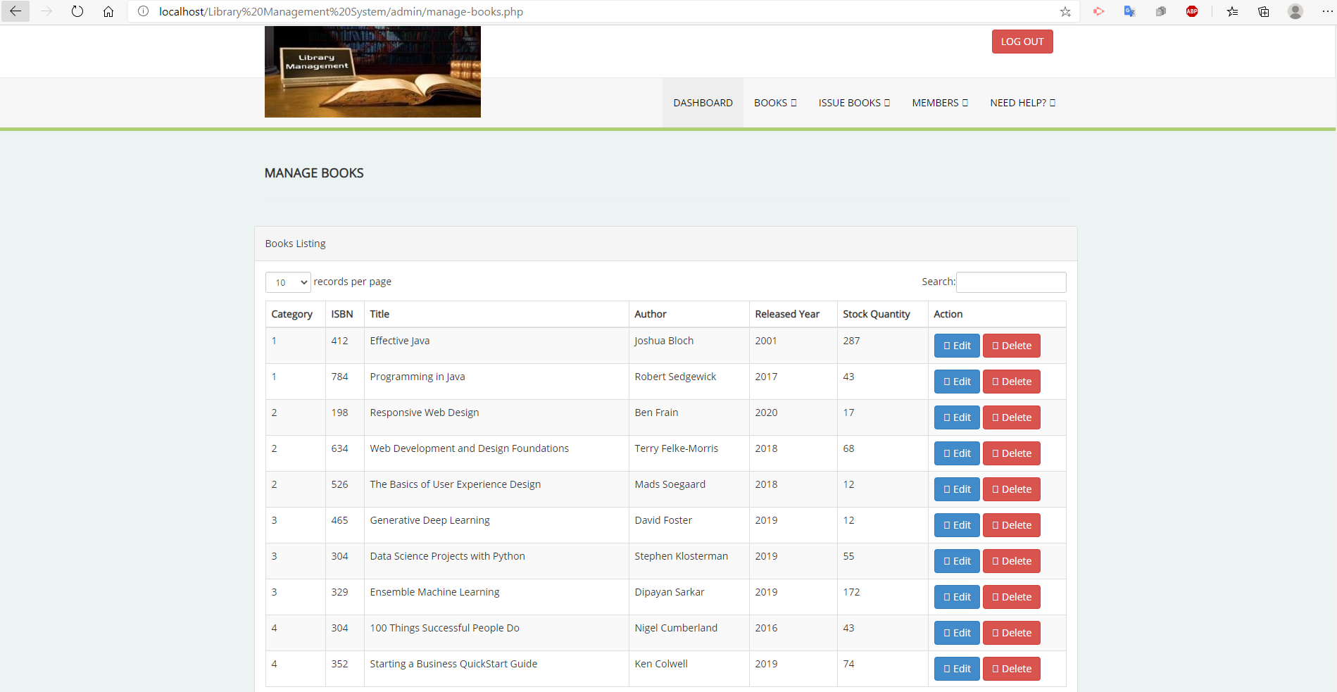

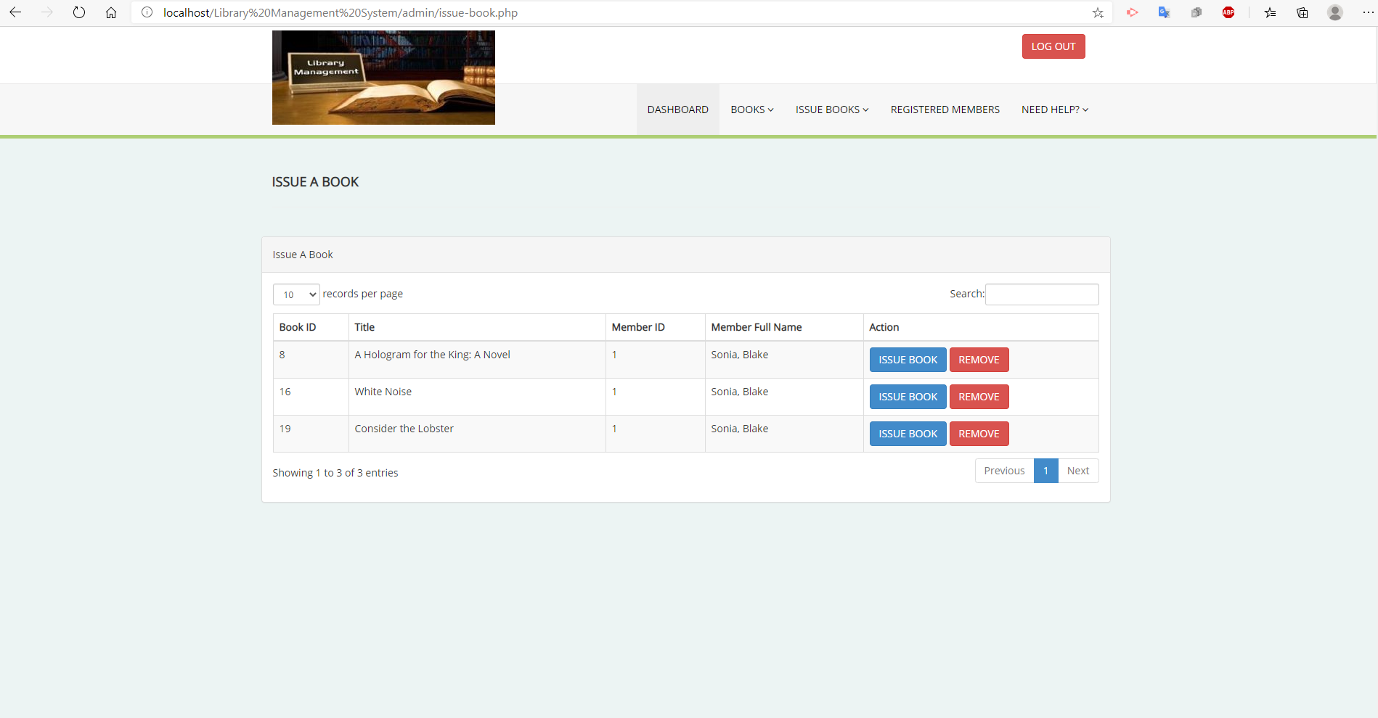

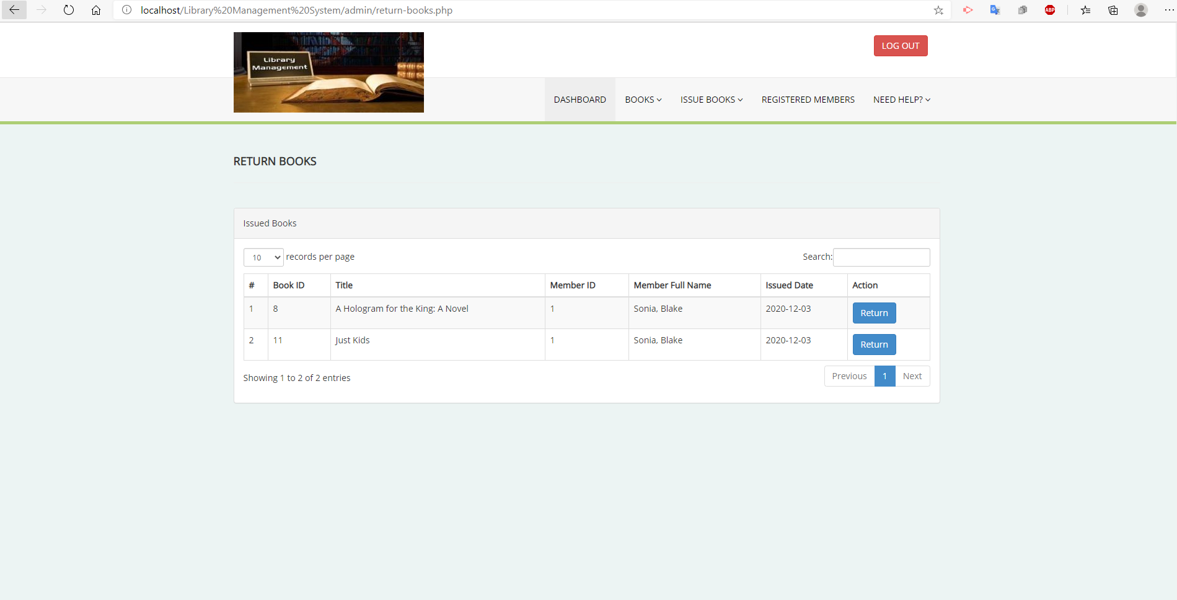

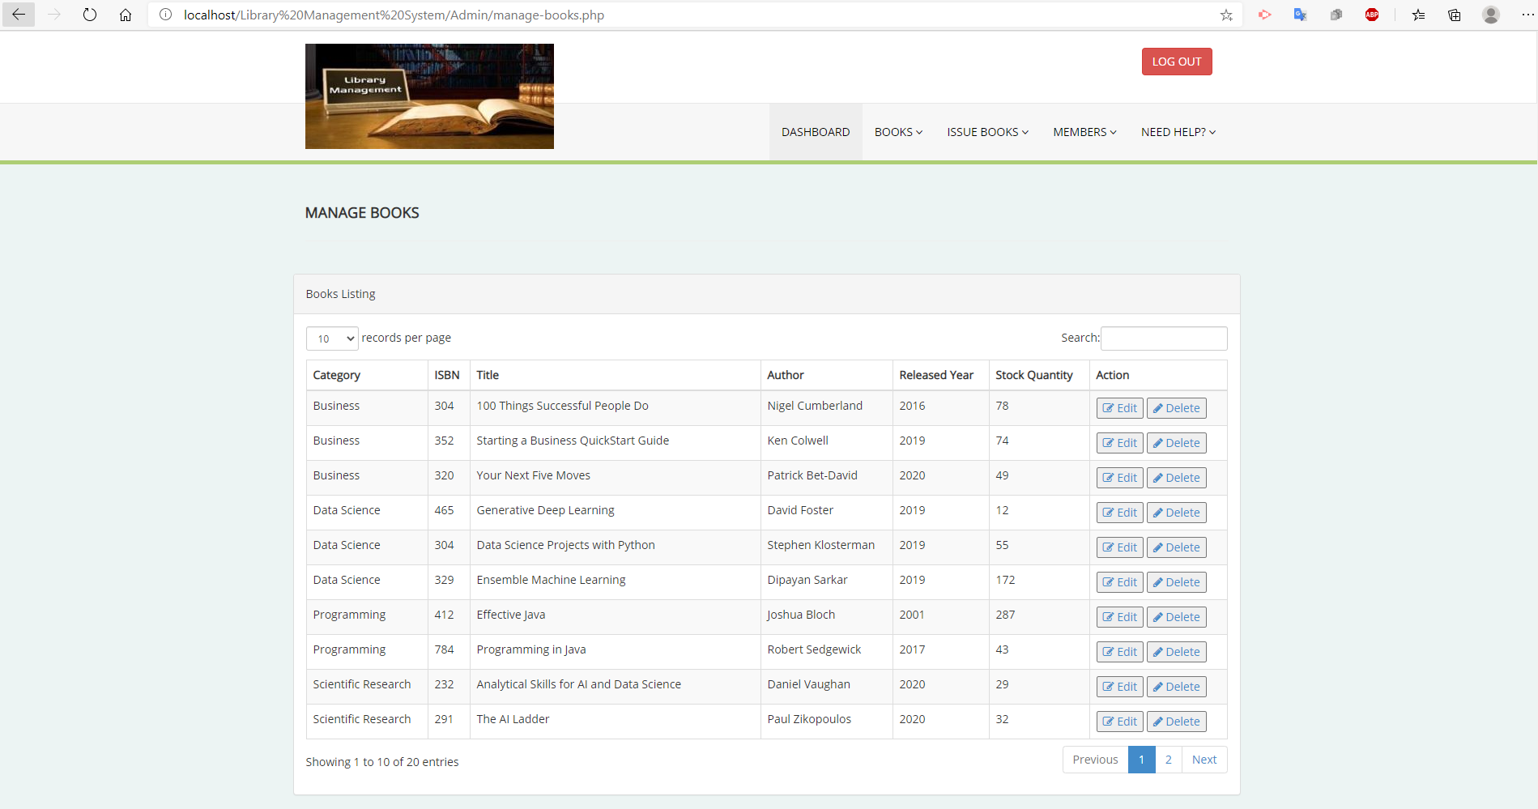

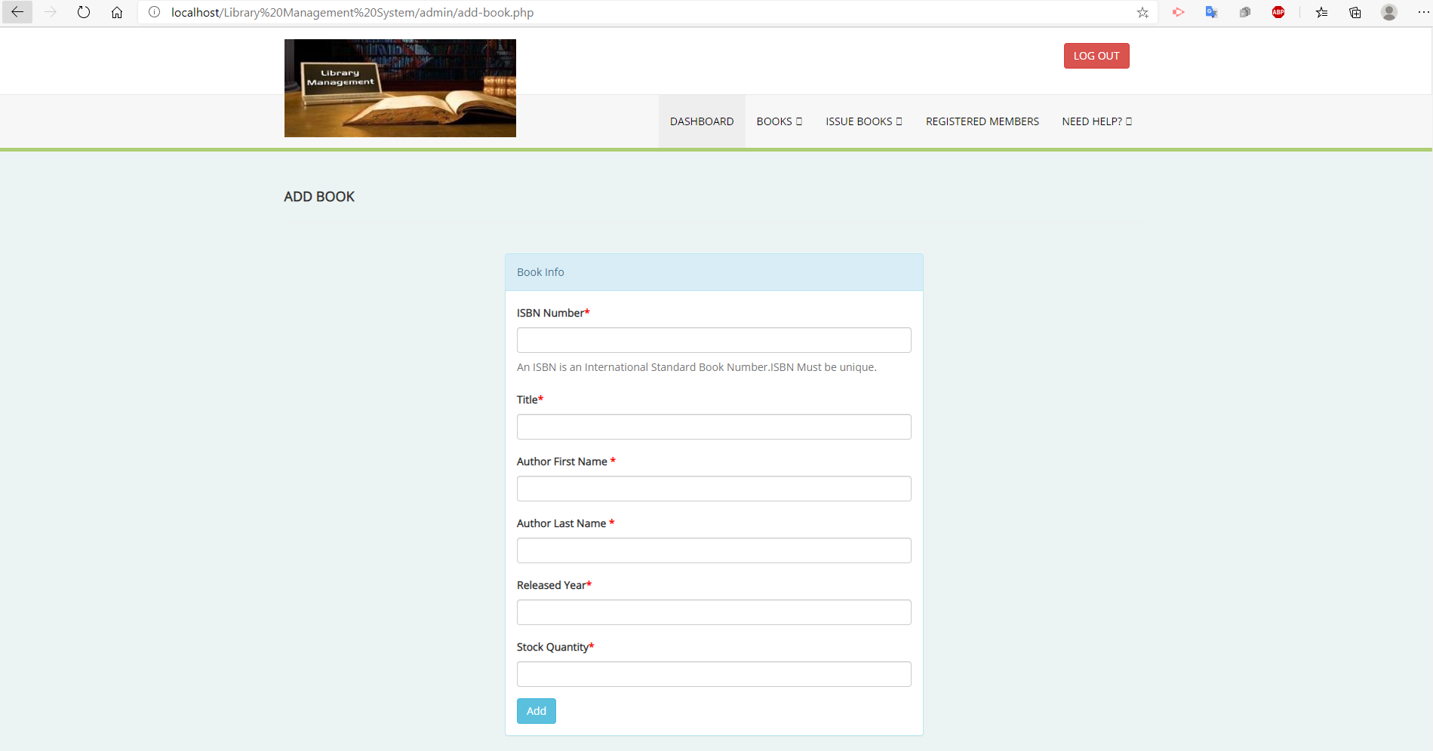

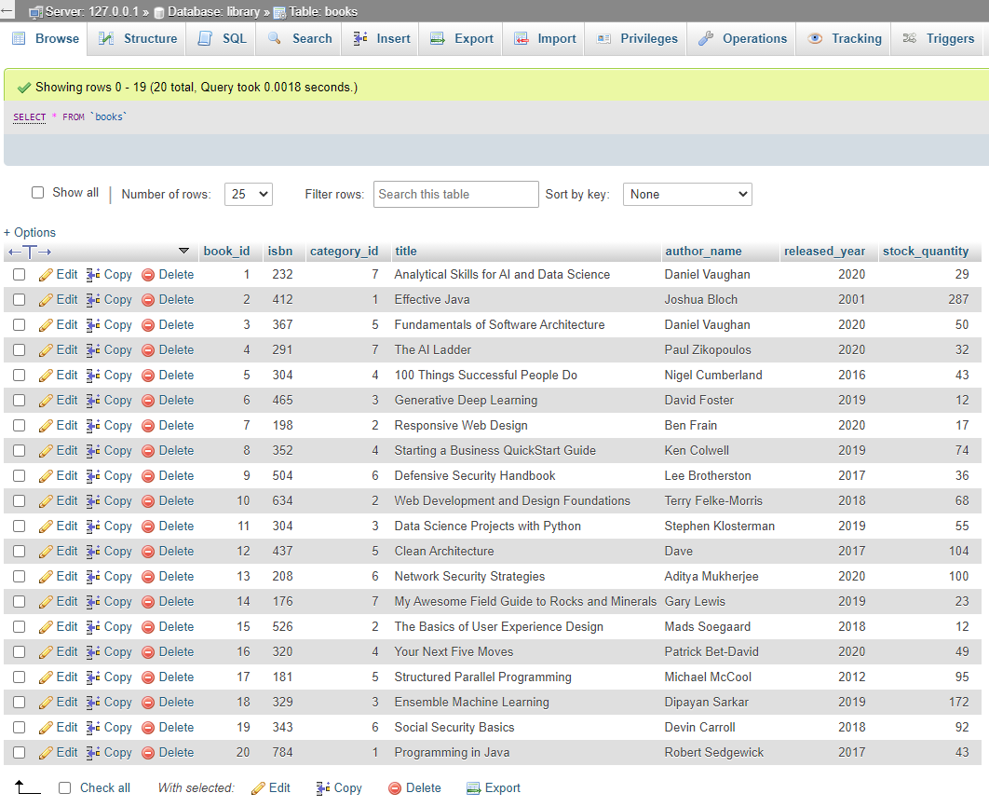

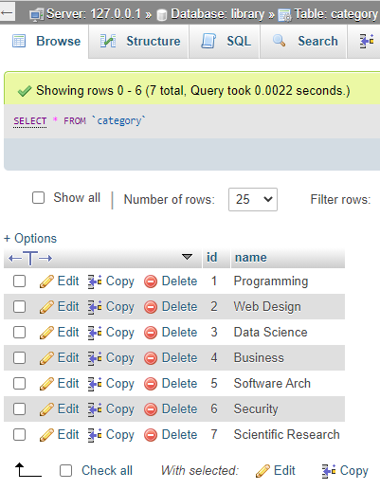

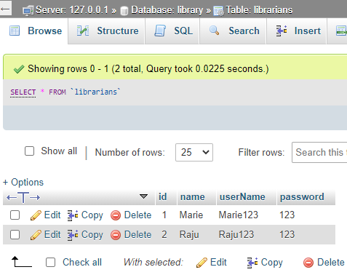

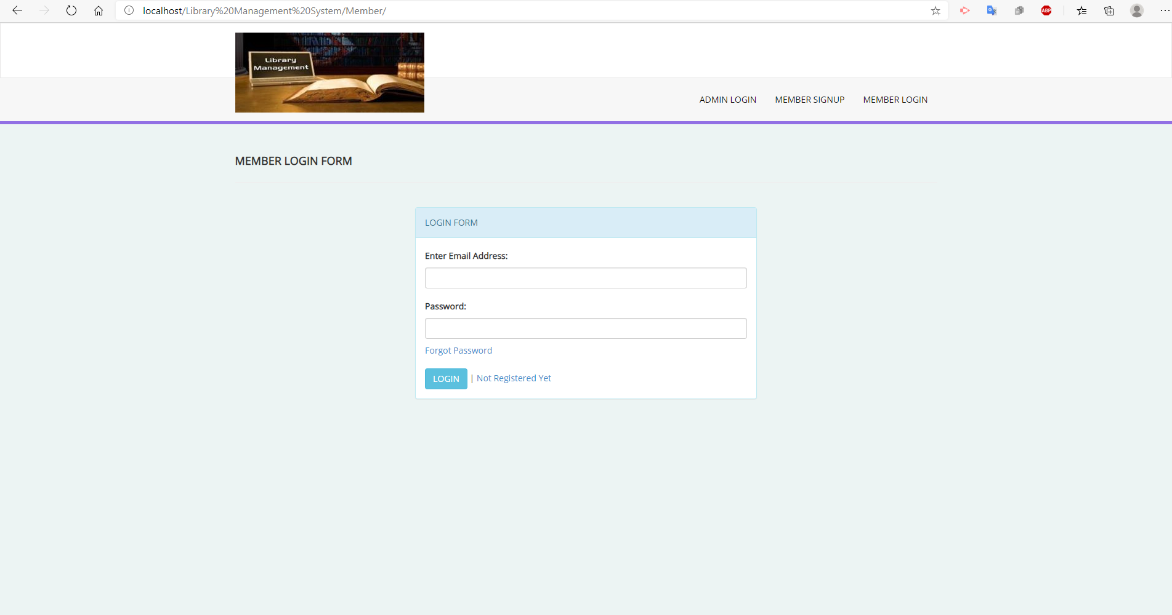

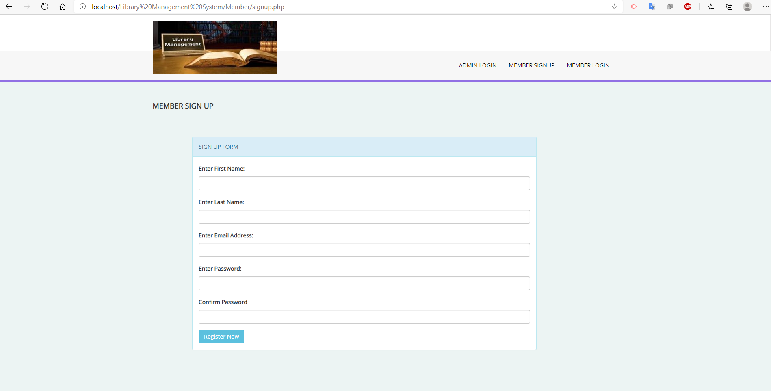

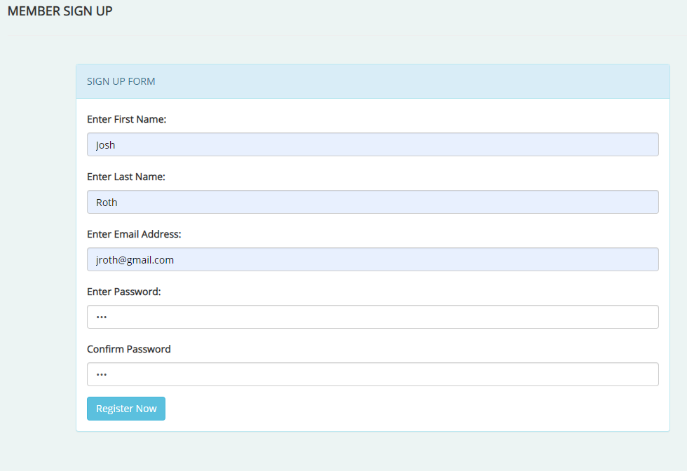

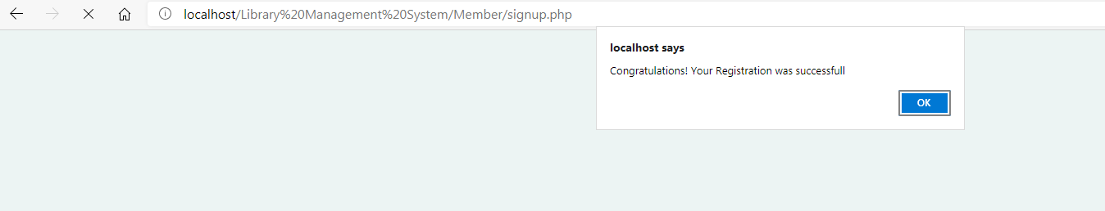

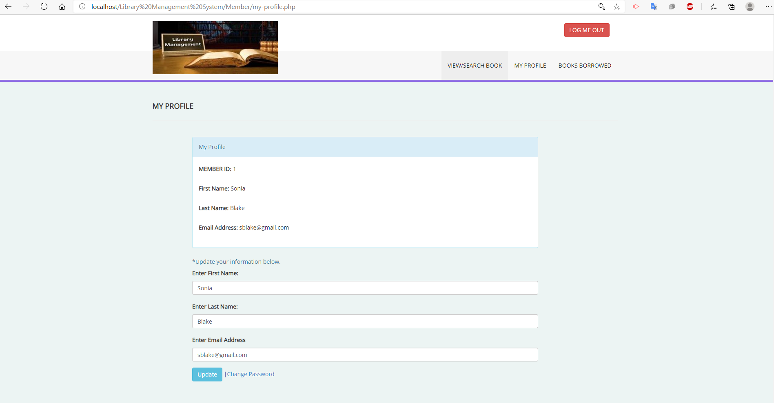

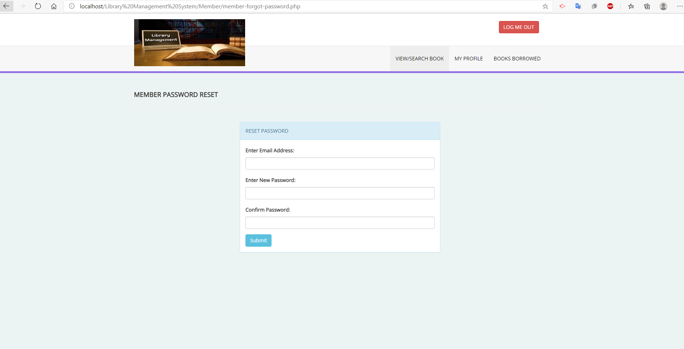

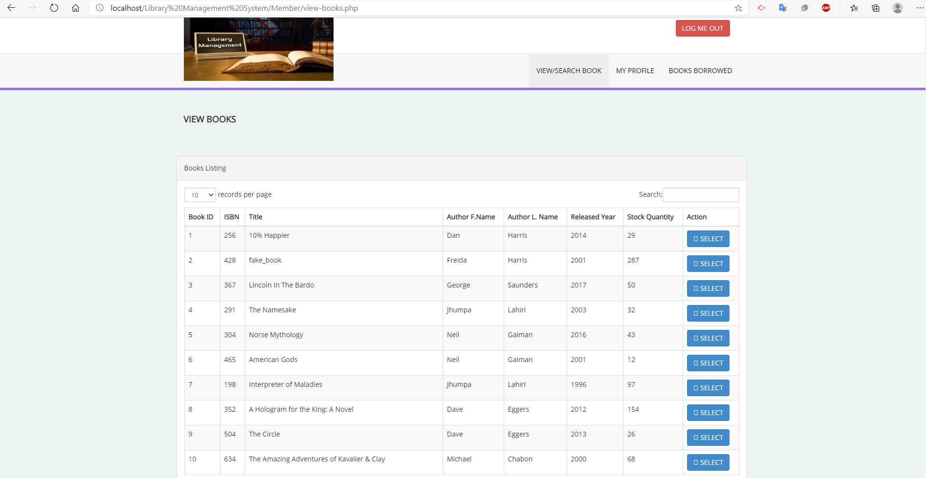

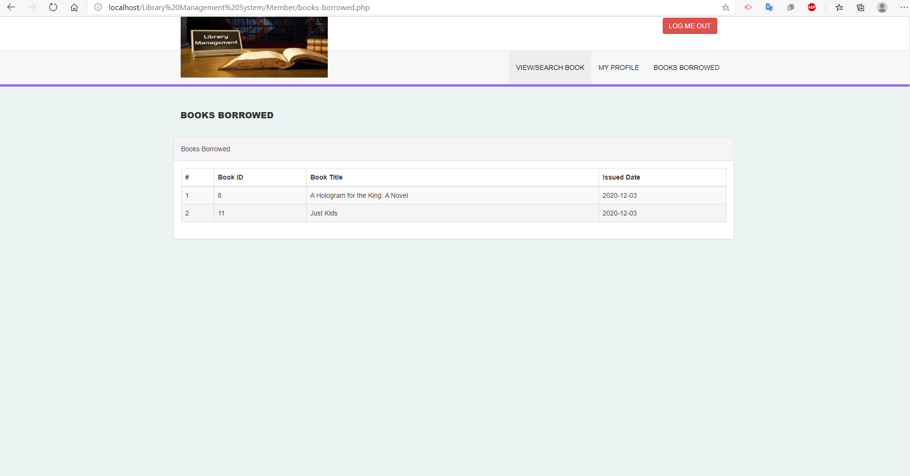

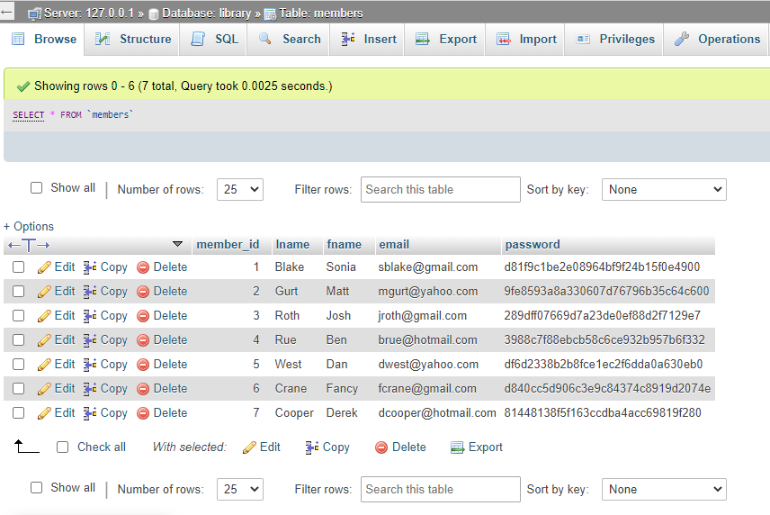

**A reflection. What did you learn? And how you can benefit from this in your future career?**

**Marie**

Working on this project was fun, but also stressful because of the many errors I kept getting in the code when I tried to implement something I had learned. I really like PHP and MYSQL and what you can do with those programs. In MAC172, I didn’t fully get a chance to understand a lot of things, like how to edit, delete users from the database for example. I love learning and I did learn many things along the way while working on this project. My team member Raju was a great partner to have. Whenever I had an issue or an error on my side he was more than willing to help and after spending over an hour on Zoom we figured out the reason why I couldn’t fully run the system which made me feel really happy in the end because we were able to figure it out. A way what I learned can benefit me in my future career, well, when I get stuck on a project and I get ton of errors I can search for a fix and I can also look within the code to find the reason why that error occurs. I’m proud that I can do that. All in all, it was a good experience for me and I couldn’t ask for a better teammate.

**Raju**

While working on this project, I have had a chance to expand my skills of front-end web development which I learned in MAC172 class. In addition to expanding my front-end skills, I learned new skills of back-end development using PHP and MySQL. For instance, how to manipulate the data from a database, how to handle a request coming from the client side etc. I enjoyed working with Marie. We had fun while working on this project. It was a great collaboration with Marie.

**Project code**

Code is in the Zip folder.

**A five minutes video that include a demo of your project. This should include a demo on how you run the code, what your website can offer (the features/functions). Just imagine that you explain what your website can do to a client.**

Video is in the Zip folder.